Wood for Guitars

In this activity, participants will measure the stiffness per unit weight of wood samples.

Learning Objectives:

- Students will accurately determine the dimensions of their wood samples
- Students will measured deflections of their cantilevered samples
- Students will calculate the elastic modulus of their samples
- Students will calculate the stiffness/weight ratio of their samples

Materials Required:

- Wood samples approximately 610mm x 32mm x 4mm (about 24in x 1.25in x 0.16 in).
- A dial or digital caliper
- A ruler or printed scale
- An electronic scale capable of measuring 200gm
- A weight of approximately 100gm (it doesn’t need to be calibrated since you’ll weigh it)
- Two clamps (Quick Grips or C‐clamps work well)
- Masking tape
- A mechanical pencil
- A bench with a squared edge
- A sandwich bag
- A paperclip

Safety:
Be sure to keep feet from beneath the weight in case the wood sample breaks

References:

  - Mott, R (2007) Applied Strength of Materials, 5th ed. Prentice Hall.
  - Bergman, et al, Forest Products Lab (2010) Wood Handbook, Wood as an Engineering Material, FPL‐GTR‐190, www.fpl.fs.fed.us/products/publications.

Standards:

Procedure
The object is to calculate the material stiffness of several species of wood and to compare the stiffness to weigh ratios. The stiffness of structure (like a small wood beam) is determined by its geometry and the material stiffness. All the beams should be the same length and cross-sectional shape, so any differences in stiffness are due to the material properties. The material stiffness is called the modulus of elasticity. The stiffness due to the cross-sectional shape of the beam is called the area moment of inertia.

The procedure is:

  - Using the caliper, determine the width and thickness of two specimens. It is a good idea to write dimensions right on the specimens. If you want to speed the activity, you can provide the specimens with the dimensions already written on them.

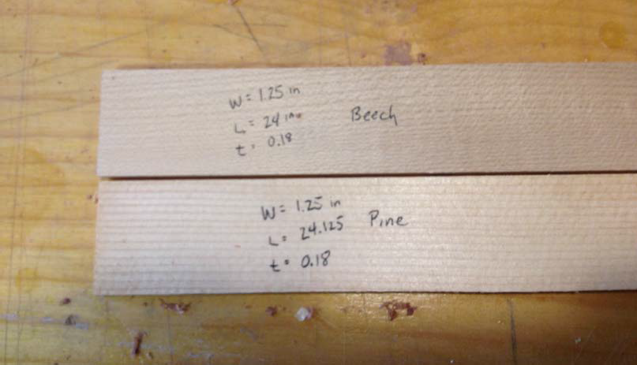

Units: To be consistent with international standards, it makes sense to do all measurements and calculations in metric units. All forces should be in Newtons, all masses should be in kilograms and all lengths should be in meters.

  - Using the electronic scale, weigh each of your specimens. You’ll need to keep track of the specimens, so you should number or label them. Record the weights in kilograms (which is actually mass, not weight).
  - You’ll need to know the density of each of the wood specimens. Calculate the volume in m3 for each specimen. Divide the mass by the volume to get mass density. Record the density for each specimen.

  - The most complicated measurement is recording displacement due to a load. The first step is to cantilever the two specimens. Clamp the two specimens to the table so they a parallel to each other and closely separated (less than 25.4mm or 1 inch). Also make sure that they have the same free length from the table. If possible, clamp them so that at least 559mm (about 22 inches) extends out from the table. Be sure that the edge of the table is a 90 degree corner to form a good boundary condition. Don’t use a table edge that has been rounded.

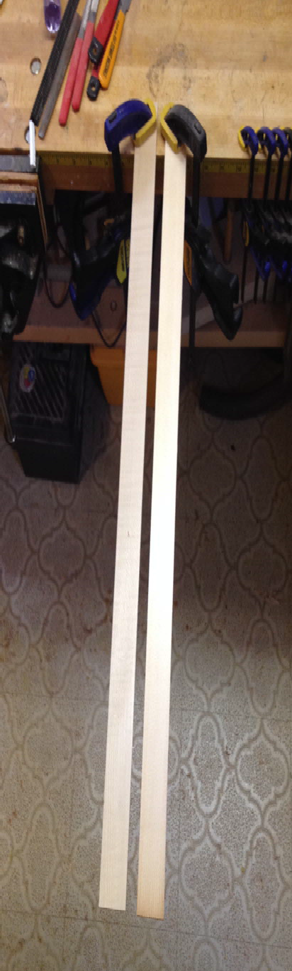

  - The ends of the two beams should be as close to the same height as possible. It is typical for one or both of the sticks to have a slight curve, so arrange them to have as little difference as possible. Select one of them to be your reference beam (The one that isn’t loaded) and one to be your test beam (the one that is loaded). Tape a small piece of cardboard or a printed scale to your reference beam as shown.

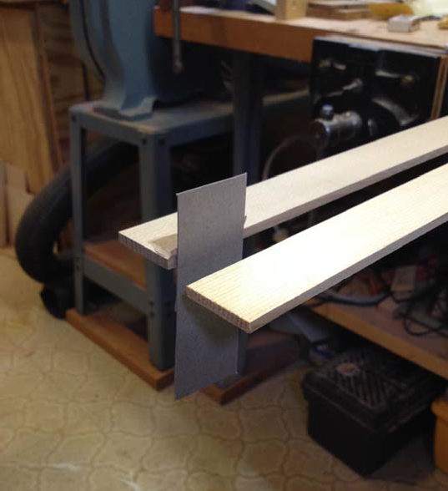

  - Put a light pencil mark on the cardboard that matches the height of the test beam. This will serve as a reference point.

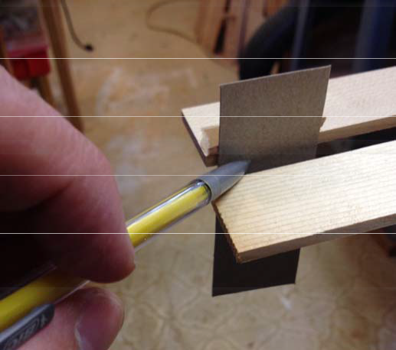

  - You will need a weight to load your specimens. A socket works very well. If sockets are not available, you can use sealable sandwich bags containing coins, screws or other heavy materials. Weigh the bag or the weight and record the mass in kilograms. Multiply by the acceleration of gravity to get weight in Newtons.
  - Put your weight on the test specimen. If you are using a bag, you can form a hook out of a paperclip to suspend it from the end of the beam. When the beam has stopped vibrating, use the mechanical pencil to put a second mark on the cardboard showing how far the test specimen has deformed due to the load. Perform this test for each specimen and record the deformation in meters.

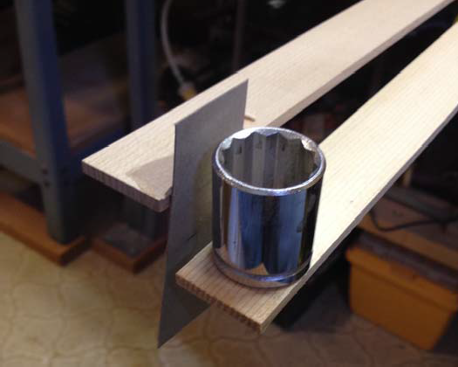

Aside: Wood displays a property known as creep. That means that it continues to deform slowly after a load is applied. The beams used in this experiment may creep when loaded, so you may notice that your test beam continues to move just a little. Rather than try to wait until it stops creeping, record the deformation right after applying the load.

  - The difference between the two marks is the deformation due to the weight. Once you have a deformation number for one test specimen, make it the reference beam and make the other the test beam. Then, repeat the test.

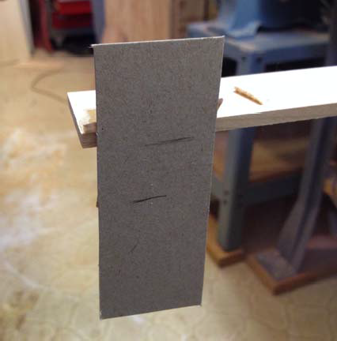

  - Once you have the displacements, you can calculate the modulus of elasticity for each beam. To do that, you’ll need to use the equation for the displacement of a cantilevered beam:

You’ll need some definitions:

∆y =
FL3 3EI

F = Force applied – weight in this case. Force is in Newtons
L = Length of beam starting from the edge of the table, L is in meters
I = Area moment of inertia of the cross-section of the beam. This number describes the stiffness of the beam due to its cross-sectional shape

$$I=\frac{1}{12}bh^{3}$$

Where b is the width of the beam and h is the thickness of the beam. Both dimensions should be in meters. The units for I are m⁴.

E = Elastic modulus. This is stiffness due to the material

The displacement equation can be re-arranged

F3
E =
3I∆y

We can measure or calculate everything on the right hand side of the equation. Note that elastic modulus is likely to be a very big number. For example, the elastic modulus of hard maple (often used for necks) is listed as approximately 12 ×109 Pa or 12 GPa.

  - The last step is to calculate the ratio of stiffness to weight. For each specimen, divide the elastic modulus in GPa by the density. Record the resulting values and put them in order from the highest to the lowest.

The woods most favored for acoustic guitars are often the ones with the highest stiffness to weight ratio. In particular, Sitka spruce is favored for the soundboards of acoustic guitars. Electric guitars can be made with a wider range of woods. It is typical to use hard maple or mahogany for the neck and something less dense for the body. Alder and Basswood are typical choices for body wood, though soft maple is sometimes used.

