Scale Length, Frequency, & String Tension
String tension is determined by vibrating length, mass, and pitch. The string diameter alone does not determine a string’s tension. By using different raw materials (nickel-plated steel or phosphor bronze, etc.) or by varying the ratio between the core and the wrap wire, two strings with the same diameter, tuned to the same pitch, could have two different tensions.
There are many factors other than string gauge that determine the actual and perceived string tension on your instrument, such as scale length, which is the distance between the nut and the saddle. The longer the scale, the higher the tension for the same string tuned to the same pitch – for example, a standard Fender™ guitar at 25½” scale has more string tension and will feel stiffer than a standard Gibson™ 24¾” scale guitar, even if both are tuned to the same standard pitch. Some players adjust for this by using slightly heavier gauges on shorter scale guitar than on longer scale guitars.
Learning Objectives:

String tension is measured in pounds of pull per string. When all of the tensions of each string are added up, you get the “set tension” for that set. For example, to change the tuning of one string, select a string gauge that will offer a similar tension to the string you are replacing, but that can be tuned to the desired pitch.
- Students will demonstrate understanding of the mathematical concepts of scale length by determining the exact scale length of their own guitars.
- Students will demonstrate understanding of the mathematical concepts of string tension by interpreting, explaining, solving, and applying the equation for calculating string tension.
- Students will demonstrate understanding of rewriting math formulas to highlight a quantity of interest by deriving an equation for the unit weight of a guitar string.

Materials Required:

Basic calculator, paper, and pencil
A guitar to use for determining scale length

Safety:

safetys:

N/A

References:

Common Core State Standards Initiative. (2012). Mathematics>home>mathematics. Retrieved 5 January 2014 from http://www.corestandards.org/Math

D’Addario Catalog. (2013). String tension 101. Farmingdale, NY: J. D’Addario & Company, Inc.

D’Addario Catalog Supplement. (2013). String tension specifications. Farmingdale, NY: J. D’Addario & Company, Inc. Retrieved 5 January 2024 from http://www.daddario.com/upload/tension_chart_13934.pdf

Standards:

Common Core State Standards for Mathematics aligned with this activity:

CCSS.Math.Content.HSA-SSE.A.1b Interpret complicated expressions by viewing one or more of their parts as a single entity. For example, interpret P(1+r)^{n} as the product of P and a factor not depending on P.

CCSS.Math.Content.HSA-REI.A.1 Explain each step in solving a simple equation as following from the equality of numbers asserted at the previous step, starting from the assumption that the original equation has a solution.

CCSS.Math.Content.HSA-REI.B.3 Solve linear equations and inequalities in one variable, including equations with coefficients represented by letters.

CCSS.Math.Content.HSA-CED.A.4 Rearrange formulas to highlight a quantity of interest, using the same reasoning as in solving equations. For example, rearrange Ohm’s law V = IR to highlight resistance R

CCSS.Math.Practice.MP1 Make sense of problems and persevere in solving them.

CCSS.Math.Practice.MP4 Model with mathematics.

CCSS.Math.Practice.MP5 Use appropriate tools strategically.

CCSS.Math.Practice.MP6 Attend to precision.
Activity

To determine the tension at which a string vibrates will require three pieces of information: the unit weight, the scale length, and the frequency of the string. Use the graphic and formula below to calculate the exact tension for any string, based on the scale length of your particular instrument.

Frequency (in Hertz) of the Desired Pitch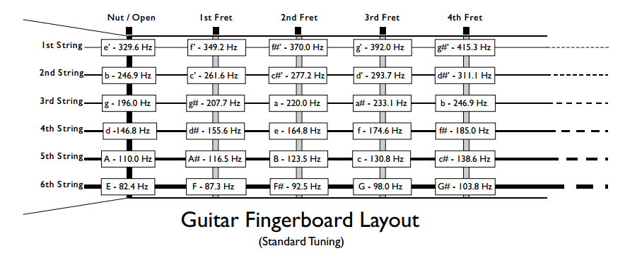

Exercise #1: Calculate String Tension
For your own guitar, determine the string tension, in pounds, of an open low E-string with a unit weight of 0.00038216 pounds per linear inch. Use the Guitar Fingerboard Layout graphic provided to locate the frequency of an open low E-string.

To calculate, you will also need to know the scale length of your guitar. A guitar's scale length is determined by measuring the distance from the front edge of the nut, where it butts against the end of the fingerboard, to the center of the 12th (octave) fret, then doubling that measurement. Use this information to find the scale length of your guitar. If an actual guitar is not available to you at the moment, use the Fender 25-1/2 " guitar scale commonly used on Stratocasters® and Telecasters® for the purpose of this calculation.

To calculate the Tension of a string in pounds, use this equation:

T = [UW x (2 x L x F)²] ÷ 386.4

T = Tension. String tension is measured in pounds of pull per string.
UW = Unit Weight. Unit weight is expressed in pounds per linear inch (lb/in).
L = Scale Length. This is the vibrating length of the string. (To determine a guitar’s specific Scale Length, first measure then double, the distance from the nut to the center of the 12th fret.)
F = Frequency or pitch. This is the pitch at which you will be tuning the string, expressed in cycles per second (Hertz). (See Guitar Fingerboard Layout above to select frequency)

Exercise #2: Calculate Unit Weight
For your own guitar, determine the unit weight, in pounds per linear inch, for a desired string tension of 22.0 pounds of pull.

If you already know what tension you want the string to have, in this case, 22.0 pounds, you can first calculate the string unit weight, then use the D’Addario String Tension Specifications to locate a specific string with approximately the same desired unit weight.

Use the Guitar Fingerboard Layout graphic provided to locate the frequency, or pitch, of an open low E-string. Use the same scale length you used from Exercise #1.

After you have determined the unit weight of the string, use the D’Addario String Tension Specifications to locate a low E-string with approximately the same calculated unit weight and desired tension and note the actual item # (string gauge).

To calculate the Unit Weight in pounds per linear inch, rewrite the Tension equation to solve for Unit Weight:

UW = (T x 386.4) ÷ (2 x L x F)²

T = Tension. String tension is measured in pounds of pull per string.
UW = Unit Weight. Unit weight is expressed in pounds per linear inch (lb/in).
L = Scale Length. This is the vibrating length of the string. (To determine a guitar’s specific Scale Length, first measure, then double, the distance from the nut to the center of the 12th Fret.)
F = Frequency or pitch. This is the pitch at which you will be tuning the string, expressed in cycles per second (Hertz). (See Guitar Fingerboard Layout above for desired frequency)

Answers to Exercises #1-2

Final answers may vary depending upon your guitar’s specific scale length.

Exercise #1: Calculate String Tension

To calculate the Tension of a string in pounds, use this equation:

T = [UW x (2 x L x F)²] ÷ 386.4

T = unknown
UW = 0.00038216 pounds per linear inch
L = 25.5” (or use the actual scale length of your own guitar)
F = 82.4 hertz

T = [0.00038216 x (2 x 25.5 x 82.4)²] ÷ 386.4
T = [0.00038216 x 17660165.76] ÷ 386.4
T = 6749.0089468416 ÷ 386.4
T ≈ 17.466 pounds

Exercise #2: Calculate Unit Weight

To calculate the Unit Weight in pounds per linear inch, rewrite the Tension equation to solve for Unit Weight:

UW = (T x 386.4) ÷ (2 x L x F)²

T = 22.0 pounds
UW = unknown
L = 25.5” (or use the actual scale length of your own guitar)
F = 82.4 hertz

UW = (22 x 386.4) ÷ (2 x 25.5 x 82.4)²
UW = 8500.8 ÷ 17660165.76
UW ≈ 0.0004813 pounds per linear inch

Possible answer for string gauge of low E at 22.0 lbs. tension and ≈ 0.0004813 lb./in:

NW052 Nickel-plated Steel Round Wound

