Manufacturing vs. Custom

Description of Activity
- Students will explore the manufacturing process of electric guitar building and custom guitar building.
- The purpose of this activity is to have the students to analyze the differences in the processes.
- This activity is used for Engineering or Mechatronic Classes
- Grade Level: 9-12

Learning Objectives:

(List measureable objectives)
- Students will research electric guitar manufacturing videos. Example: Gibson, Fender
- Students will research electric guitar custom building.
- Students will compare and contrast the process of building electric guitars.

Standards:

Examining All Aspects of an Industry – CTE Standards
- Examine aspects of planning within an industry/organization.
- Examine aspects of management within an industry/organization.
- Examine aspects of financial responsibility within an industry/organization.
- Examine technical and production skills required of workers within an industry/organization.
- Examine principles of technology that underlie an industry/organization.
- Examine labor issues related to an industry/organization.
- Examine community issues related to an industry/organization.
- Examine health, safety, and environmental issues related to an industry/organization.

Materials Required:

- Computer
- Internet
- Word/Website Editor/Blog

Safety:

safetys:

- No safety concerns

References:

- YouTube Videos on Guitar Manufacturing

Activity:

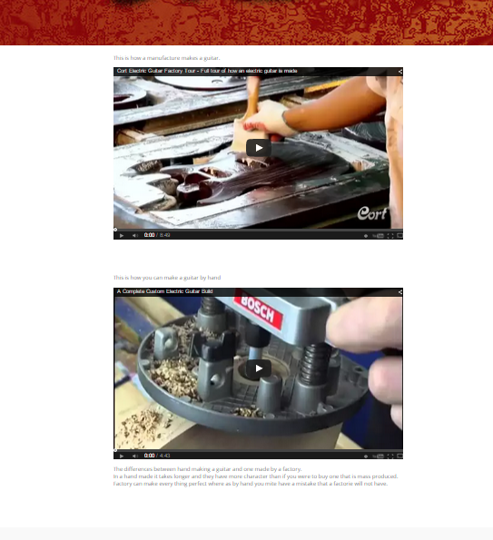
- Students will research YouTube videos on electric guitar manufacturing and custom electric guitar building. After their research they will then compare and contrast the differences of the two processes.
Example: Student Blog of the two videos with descriptions

Quiz:

Directions: List the differences of the two types of manufacturing processes.
 | Custom Manufacturing | Mass Production
Quantities | Small | Large
Manufacturing method | Small / one person shop | Assembly Lines
Manufacturing source | Human | Humans and/or machines
Labor costs | More | Less
Human error | More | Less
Design changes | Easy | Difficult
Business Model | Made to order | Large inventory / JIT
Production time | High | Low
Quality Assurance | High | Low

Reviewing Faculty Cohort Members:

- Bruce.Toney@marion.k12.fl.us" <Bruce.Toney@marion.k12.fl.us>,
David DeLade <dmdelade@wsfcs.k12.nc.us>,

