Guitar necks: The compression and tension of a neck

Changing the tension on a truss rod means that you are changing the curvature of the neck? How much force is needed to change the neck? Using Finite element analysis to calculate the force needed to bend a guitar neck. Included is a complete set of inventor assembly / part drawings to assembly a basic neck (do not use it to carve or router a neck).

Learning Objectives:

- Students will assemble a complete neck in a 3D CAD software package
- Students will test the finite element analysis of the neck
- Students will determine the amount of force needed to deflect the neck and / or break the neck

Materials Required:

- Autodesk Inventor or Solidworks software
- Youtube video access for general instruction

Safety:

safetys:

Do not try to over stress a physical guitar neck, severe injury may occur. Use Computer modeling to test the concepts of stress loading on neck and what a truss rod does.

References:

Dropbox location of Inventor files and assemblies : https://dl.dropboxusercontent.com/u/16545857/Truss%20Rod%20ASSY%20Design%20files.zip

http://formulas.tutorvista.com/physics/beam-deflection-formula.html

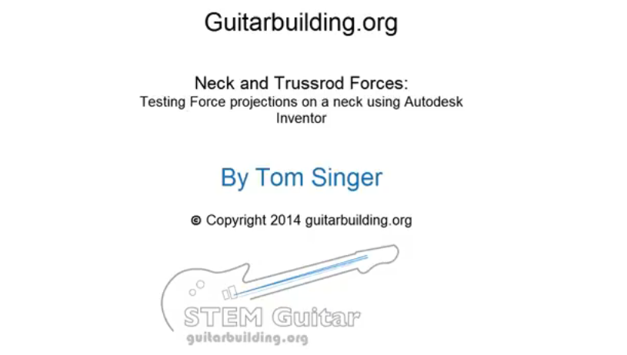
Link to you tube video

http://youtu.be/V7nIawuIcJM

Standards:

List The Common Core Math or Next Generation Science Standard mapping:

HSS-ID.A.3 | Interpret differences in shape, center, and spread in the context of the data sets, accounting for possible effects of extreme data points (outliers).
HSN.Q.A.1 | Use units as a way to understand problems and to guide the solution of multi-step problems; choose and interpret units consistently in formulas; choose and interpret the scale and the origin in graphs and data displays. (HS-LS2-1),(HS-LS2-2),(HS-LS2-4),(HS-LS2-7)
HSN.Q.A.2 | Define appropriate quantities for the purpose of descriptive modeling. (HS-LS2-1),(HS-LS2-2),(HS-LS2-4),(HS-LS2-7)
HSN.Q.A.3 | Choose a level of accuracy appropriate to limitations on measurement when reporting quantities. (HS-LS2-1),(HS-LS2-2),(HS-LS2-4),(HS-LS2-7)

Next Gen Science Standards:

HS-PS2-3. | Apply scientific and engineering ideas to design, evaluate, and refine a device that minimizes the force on a macroscopic object during a collision.*
HS-ETS1-4. | Use a computer simulation to model the impact of proposed solutions to a complex real-world problem with numerous criteria and constraints on interactions within and between systems relevant to the problem.
HS-LS2-2. | Use mathematical representations to support and revise explanations based on evidence

- General concepts of tension and compression

The general concept of tension and compression,

When you pull objects apart they are said to be in tension
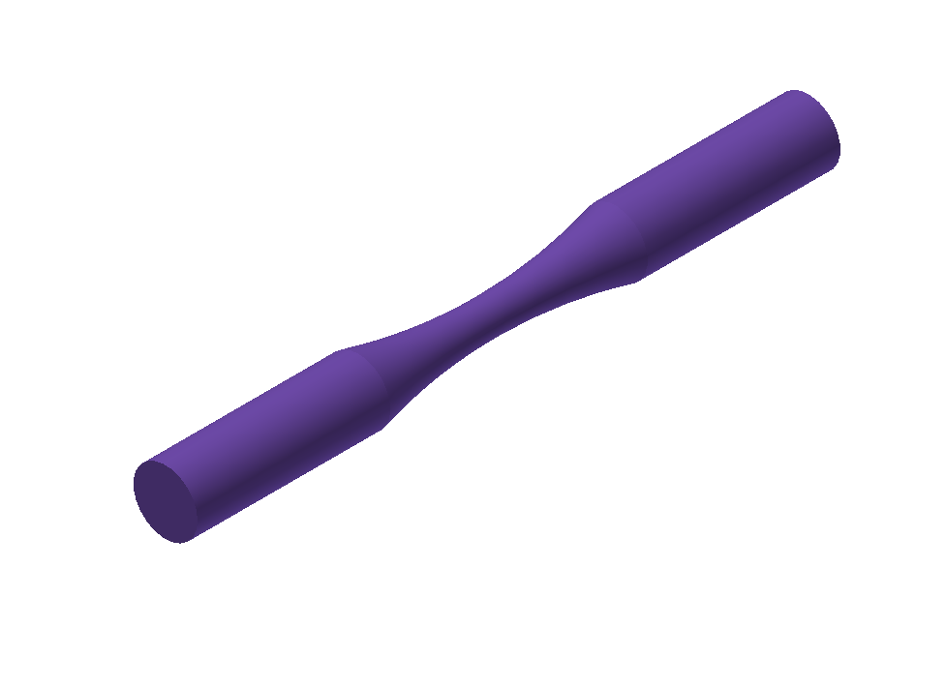
When objects are pushed together that is termed compression

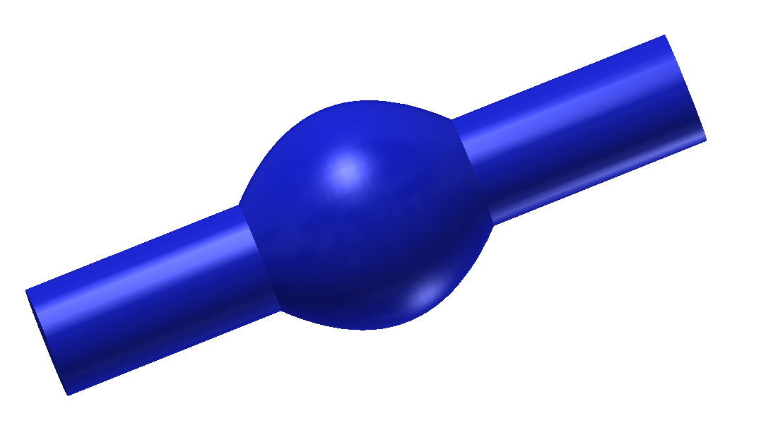

- Truss Rods - how they work – truss rods provide the mechanical force to change the shape of the wooden neck. Depending on the way they are put tension and compression the neck will either bend with a “crown” in the center of the neck or a “valley” in the center of the neck (called relief in guitar terms)
Truss rod in neutral position

Truss rod spoke turned clockwise, The truss rod flexes with a “crown” in the middle

Resulting neck shape is shown in green the neck will change shape.

Truss rod turned counter clockwise, Truss rod “valley” occurs

Resulting neck relief (or valley) is shown in the green. The neck will change shape. This increases the playability of the guitar and helps prevent string buzz on the frets. Buzzing frets occur when the string very slightly touches the fret when it is vibrating causing a buzzing sound from the string.

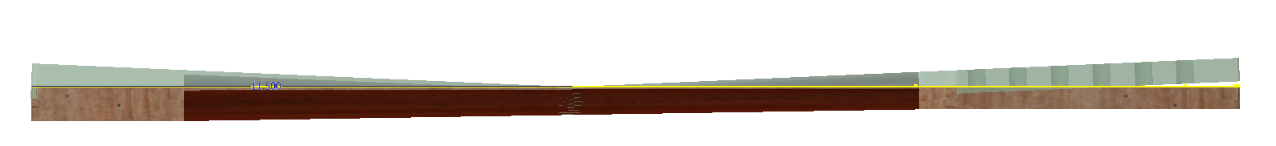

Strings play only a part in the way a neck looks and the shape a neck. The tension that the strings provide add a bit more of a valley but it is not very pronounced. The mechanical advantage of the truss rod provides the bulk of the change that the neck makes.

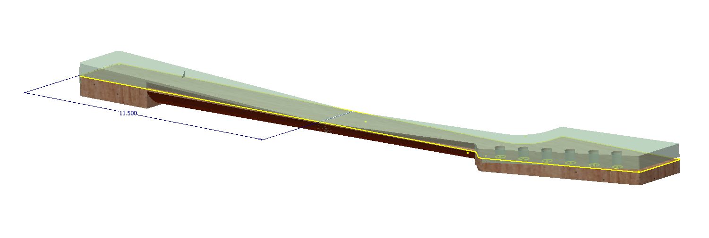

Engineering mechanics equation of beam displacement of a force that has 2 fixed ends.

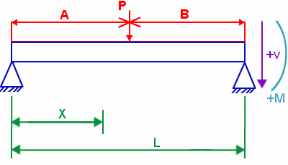
V = shear
M = moment
δ = deflection
E = modulus of elasticity
I = moment of inertia
V = PbL - P (x-a)⁰
M = PbxL - P (x-a)¹
$$δ =\frac{ P}{6EI }*[\frac{{bx}^{3}}{L }–\frac{ abx}{L}* (2L - a) - {(x - a)}^{3}]$$

This equation is what the software program uses to calculate the displacement when you place a force on the neck.

In the instructional video the neck was held in place at the neck pocket. A force was then place directly at Fret nine. This location is near the center of the neck (fret 12 is the center of the scale length).

The force applied at fret 9 will put the neck in compression, which causes a displacement in the neck.

Strings will also provide some force to the neck. Apply the string force as a pressure (across a surface instead of a single location). 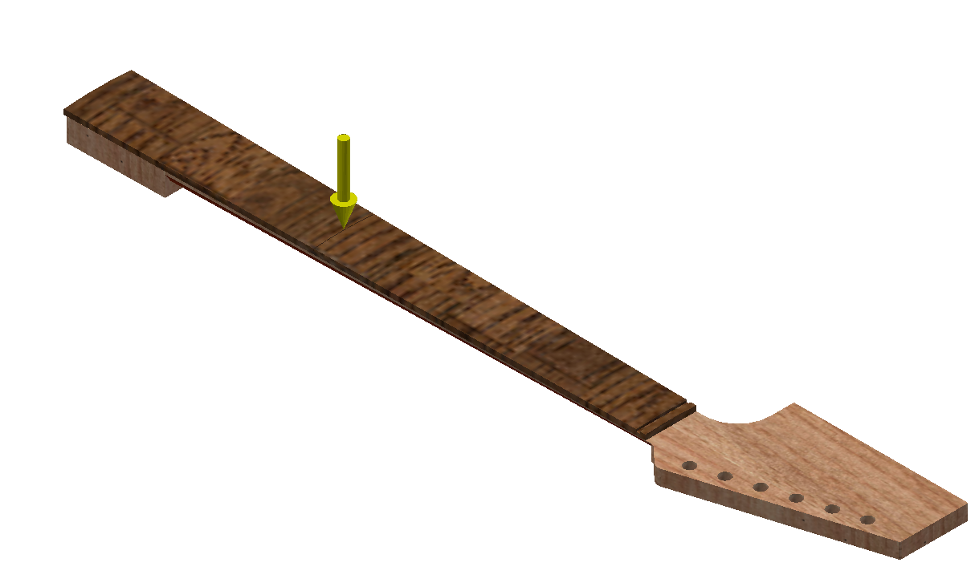
String forces applied 80 Lbs latterally and 10 Lbs vertically.
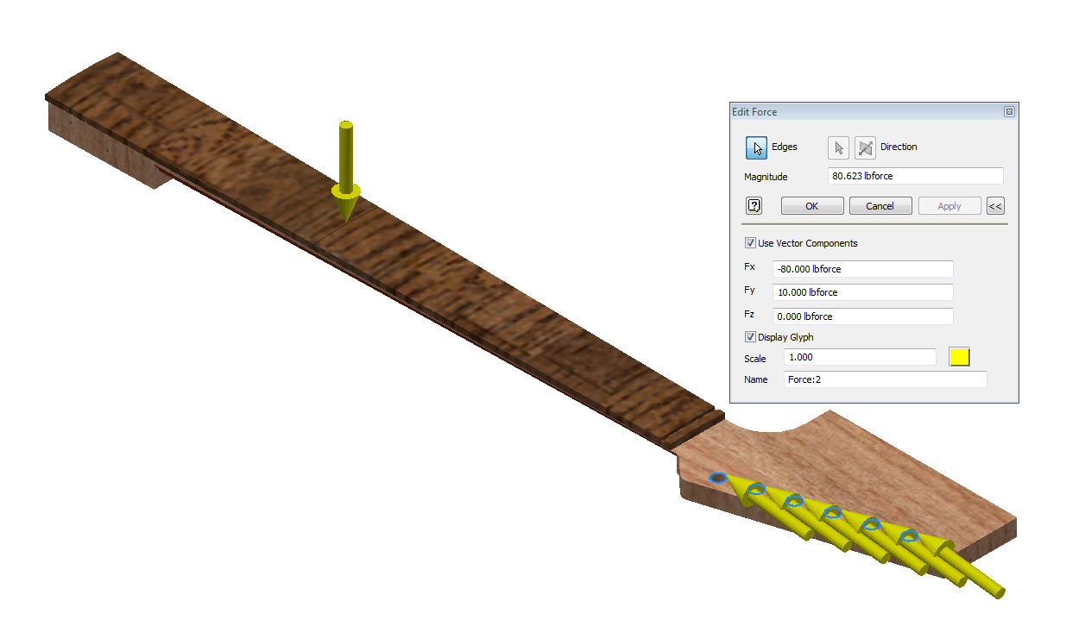
After adding a fixed edge at the back of the headstock I calculated the Displacement with the fret 9 force and the string forces applied . The Maximum displacement is .352
